**CORONAVIRUS**

**Warm-up**

**1**

**Look at this picture and write what you know about the situation:**

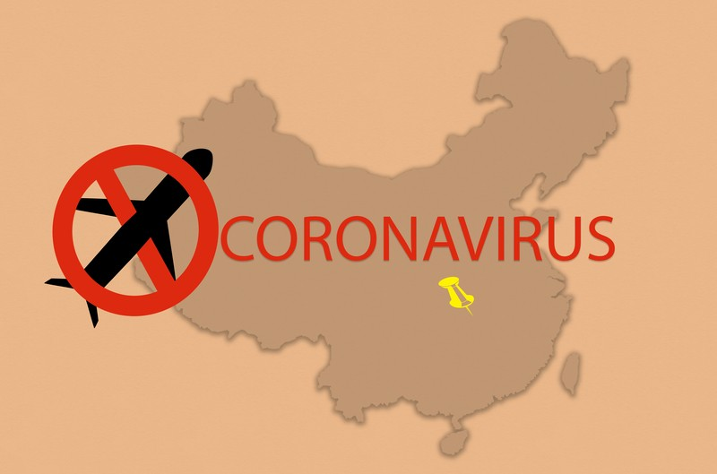

* What’s happening?

That virus has totally changed everyone's life, not being able to leave home much and without being able to do almost anything, socially speaking

* How did it start?

For a Chinese who was in China, who apparently ate something strange and because of that we caught the virus everyone

* Have similar things happened before?

I think so, I think the biggest thing was the black plague, since a lot of people died

* What might happen in the future?

Let this continue for a few more years, I think it may be the worst

**Read for main idea**

**2**

**You are going to read an article about the coronavirus epidemic. First, read the article quickly and choose the best title for it:**

* Coronavirus - the situation today
* **Coronavirus - lessons from the past**
* Coronavirus - what will the future bring

**January 13, 2020**

**1.** In December 2019, a number of pneumonia cases were reported in Wuhan, eastern China. The pneumonia is associated with a new type of coronavirus. This virus has now spread to other cities in China. There have also been cases in other countries around the world.

**2.** Coronaviruses get their names because they look like crowns under the microscope. This group of viruses cause disease in humans and other animals, including pigs and chickens.

**3.** It is thought that the new coronavirus outbreak started in a market in Wuhan, which sold meat and live animals. Scientists say that the virus is not closely related to any human virus currently known.

**4.** The World Health Organization has told countries around the world to track respiratory infections in their populations. There is currently no vaccination against the corona virus.

**5.** The Wuhan coronavirus outbreak is similar to the 2002-03 epidemic of SARS (severe acute respiratory syndrome) coronavirus. This outbreak, which started in south China, lasted for over nine months. It spread to 37 countries, causing 8,098 people to become ill and 774 to die.

**6.** Nearly 10% of people who were infected with SARS died. The deadly nature of the disease, the frequent human-to-human spread, and infection of hospital staﬀ contributed to the seriousness of the outbreak.

**7.** SARS was traced to several types of wild animals, which were sold as food in markets. The infected animals had no symptoms. The outbreak was stopped by closing markets and killing animals, and by treating and isolating patients.

**8.** SARS has not been seen since 2003 and it is thought that the virus has now disappeared. The new Wuhan coronavirus is similar to viruses related to SARS which are found in bats.

**9.** There are seven coronaviruses known to infect people, including the new Wuhan coronavirus and SARS. Other human coronaviruses are those that cause the common cold, as well as the deadly MERS virus.

**10.** MERS is a common cold virus that often jumps from camels to humans in the Middle East. It can cause severe pneumonia in people and spread from person to person. MERS was identiﬁed in 2012 and continues to be a signiﬁcant problem in the Middle East. Nearly 2,500 cases of MERS have been identiﬁed, causing 858 deaths.

**11.** Coronaviruses appear to jump easily between species, and the Wuhan virus could be the third time this has happened with humans in the last 20 years. In 2016, another coronavirus was responsible for 24,000 pig deaths in southern China. This particular virus jumped from bats to pigs but did not spread to humans.

**12.** How the new Wuhan coronavirus came to be in humans, and how closely it will resemble the SARS outbreak, will be a focus of ongoing research.

**13.** Outbreaks of new viruses, such as the Wuhan coronavirus, are a reminder of the need to invest in research in virus biology and evolution, how viruses infect and interact with human cells, and most importantly, to identify safe and eﬀective drugs to treat –or vaccines to prevent –serious disease.

*Adapted from theconversation.com, by Connor Bamford, Research Fellow, Virology, Queen’s University Belfast*

# Vocabulary to help

**3**

## **Before you read the article again, you need to know these words. Read this summary of the article and explain what the words in bold mean.**

The article describes how **viruses** have **spread** to humans from diﬀerent **species** of animals. People with these **infections** develop **severe symptoms** and can sometimes die. Several factors have **contributed to** these **outbreaks** of the coronavirus.

**Here are some more words you need to know. Match each word/phrase in bold from the article with its meaning.**

1. In December 2019, a number of **pneumonia cases** were reported in Wuhan, eastern China.
2. Coronaviruses ... look like **crowns** under the microscope.
3. The World Health Organization has told countries around the world to **track respiratory** infections in their populations.
4. There is currently no **vaccination** against the coronavirus.
5. SARS **was traced** to several types of wild animals, which were sold as food in markets.
6. The outbreak was stopped ... by **isolating** patients.
   1. count how many people have lung/breathing infections
   2. items worn by a king or queen on their head, usually made of gold, to show their position
   3. keeping sick people alone so that they cannot make anyone else ill
   4. medicine to prevent sickness, which is delivered into the body by a needle
   5. people who were sick with a serious disease of the lungs
   6. the origin of something was identiﬁed

**1.E.**

**2.B.**

**3.A.**

**4.D.**

**5.F.**

**6.C.**

**Read for detail**

**4**

**Now read the article again and complete the table on the next page, comparing three types of coronaviruses. If the article does not include this information, write NG (not given)**

|  |  |  |  |
| --- | --- | --- | --- |
|  | **SARS** | **MERS** | **the new coronavirus** |
| Year | 2002/2003 | 2012 | 2019 |
| Place it started | China | Middle East | Wuhan |
| How long it went on for | 1 year | Middle East | 2019 |
| Countries aﬀected (how many or  where) | 37 countries | Only Middle East | In all the world |
| How many people got ill | 8.099 | 2.500 | 111 milions |
| How many people died | 777 | 858 | 2,46 Milions |
| Source - where it came from | China | Middle East | Wuhan |

**Writing**

**5**

**Write about these topics. Use vocabulary and information from the lesson, and phrases from the useful language presented below.**

* How are the three outbreaks described in the article the same? How are they diﬀerent?  
  That everyone has had the same problem, nobody expected what was going to happen
* What should people do in the future to avoid coming into contact with coronaviruses?

Protect yourself more, be more careful, take care of people

* What can governments do to help slow down the spread of viruses?

Do not let anyone in the country pass, give free masks to all citizens and vaccinate all of us

* What two areas for future research does the author list? Which do you think is more important and why?

Reasearch on the biology and evolution of viruses and I think that both are equally important.

**Useful language for talking about something you aren’t very sure about:**

I’m not an expert, but... From what I’ve heard/read...

I guess nobody really knows, but...

...it seems to me that...

...it’s likely that...

...maybe...